Project Design Phase
Problem – Solution Fit Template

Date | 10 FEB 2026
Team ID | LTVIP2026TMIDS24974
Project Name | Toycraft Tales: Tableau's Vision into Toy Manufacturer Bata
Maximum Marks | 2 Marks

Problem – Solution Fit Template:
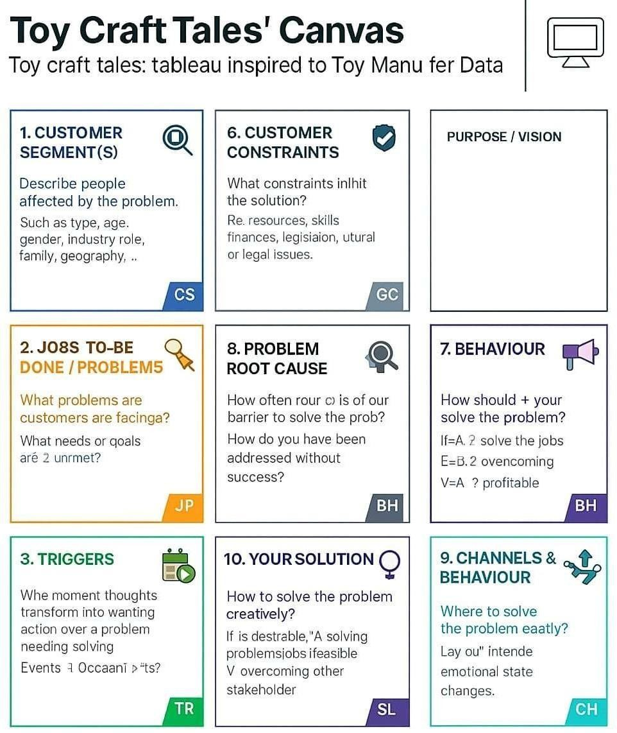
The Problem-Solution Fit simply means that you have found a problem with your customer and that the solution you have realized for it actually solves the customer’s problem. It helps entrepreneurs, marketers and corporate innovators identify behavioral patterns and recognize what would work and why
Purpose:
❑ Address complex challenges by developing solutions that align with customers’ current situations and needs.
❑ Improve the chances of success and adoption by utilizing familiar platforms, channels, and behavioral patterns.
❑ Enhance communication and marketing strategies through clear messaging and effective engagement triggers.
❑ Strengthen customer interaction by identifying the right problem–behavior match and building trust through resolving recurring or critical issues.
References:
- https://www.ideahackers.network/problem-solution-fit-canvas/
- https://medium.com/@epicantus/problem-solution-fit-canvas-aa3dd59cb4fe

